**Path Sum II:**

Given the root of a binary tree and an integer targetSum, return all **root-to-leaf** paths where each path's sum equals targetSum.

A **leaf** is a node with no children.

**Example 1:**

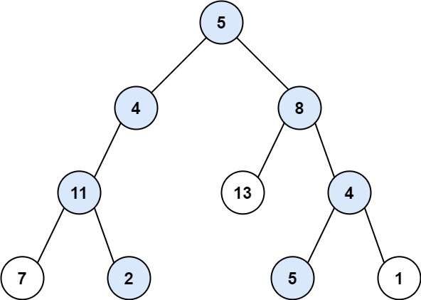

**Input:** root = [5,4,8,11,null,13,4,7,2,null,null,5,1], targetSum = 22

**Output:** [[5,4,11,2],[5,8,4,5]]

**Example 2:**

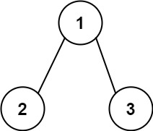

**Input:** root = [1,2,3], targetSum = 5

**Output:** []

**Example 3:**

**Input:** root = [1,2], targetSum = 0

**Output:** []

**Constraints:**

* The number of nodes in the tree is in the range [0, 5000].
* -1000 <= Node.val <= 1000
* -1000 <= targetSum <= 1000

s